LAB6 REPORT
Counters

Zhang Zhen
12.7

1. Problem Description
Consider the circuit in Figure 1. It is a 4-bit synchronous counter which uses four T-type flip-flops. The counter increments its count on each positive edge of the clock if the Enable signal is asserted. The counter is reset to 0 by using the Reset signal. In part1, we first need to implement a 16-bit counter of this type. Then, we need to add a 7-segment digital tube to this circuit to display the hexadecimal count. Ultimately, we are to implement a 4-bit version of our circuit and use the Quartus II RTL Viewer to see how Quartus II software synthesize the circuit.
In part2, we need to design and implement a circuit that displays the word HELLO, in ticker tape fashion, on the eight 7-segment displays HEX7−0. Make the letters move from right to left in intervals of about one second. The patterns that should be displayed in successive clock intervals are given in Table 1.

2. Design Formulation
Part1:
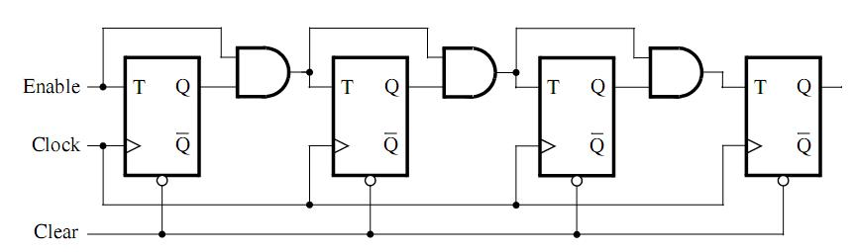
Figure 1. A 4-bit counter
Consider the circuit in Figure 1. It is a 4-bit synchronous counter which uses four T-type flip-flops. The counter increments its count on each positive edge of the clock if the Enable signal is asserted. The counter is reset to 0 by using the Reset signal. For the first T-type flip-flop, its input T depends on Enable, the second flip-flop's T depends on Enable and the first flip-flop's output Q, the third flip-flop's T depends on the second flip-flop's T and Q, and the fourth flip-flop's T depends on the third flip-flop's T and Q. From the law of the 4-bit counter's T, we can deduce the 16-bit counter's T:
T <= (enable, enable and cnt(0), t(1) and cnt(1), t(2) and cnt(2),
t(3) and cnt(3), t(4) and cnt(4), t(5) and cnt(5), t(6) and cnt(6),
t(7) and cnt(7), t(8) and cnt(8), t(9) and cnt(9), t(10) and cnt(10),
t(11) and cnt(11), t(12) and cnt(12), t(13) and cnt(13), t(14) and cnt(14));
For every T-type flip-flop, the next value of Q is equal to Q when T='0' and the next value of Q is equal to the inverted value of Q when T='1'. Based on the relationship between Q and T, we can create a component to refer to a T-flip-flop. Knowing the component T-flip-flop and the T of 16 T-flip-flops, we can get a 16-bit counter consisting of 16 T-flip-flops:
COUNTER_GEN: for i in 0 to 15 generate
T_FF: component partl port map (clk, reset, t(i), cnt(i));
end generate COUNTER_GEN;
From Q of 16 T-flip-flops we can get the 16-bit counting result, and it can be displayed from high to low every four bits on a 7-segment digital tube. The correspondence of this display can be obtained by the truth table of the common anode digital tube.

Part2:
In part2, we need to design and implement a circuit that displays the word HELLO, in ticker tape fashion, on the eight 7-segment displays HEX7−0. We can define five 7-bit logic vectors H,E,L,O,N, where H,E,L,O represent the display of the letters H,E,L,O on the 7-segment digital tube, and N represents the corresponding digital tube is all off:
constant H: std_logic_vector(0 to 6) := "1001000";
constant E: std_logic_vector(0 to 6) := "0110000";
constant L: std_logic_vector(0 to 6) := "1110001";
constant O: std_logic_vector(0 to 6) := "0000001";
constant N: std_logic_vector(0 to 6) := "1111111";
It can be found that the display on the eight digital tubes can be represented by H,E,L,L,O and three N. These eight logic vectors can be spliced together to get a 56-bit logic vector word:
signal word: std_logic_vector(0 to 55) := N&N&N&H&E&L&L&O;
To make the letters move from right to left in intervals of about one second, we can splice the word (7 to 55) with the word (0 to 6) every second to get a new 56-bit logic vector word.
word <= word(7 to 55) & word(0 to 6);
To realize the function of frequency division, we can set a 26-bit unsigned data counter and assign the initial value of each bit to 0. Whenever the rising edge of the clock arrives, the value of the counter is increased by one. When the value of the counter is equal to "2FAF080", the counter will be executed once and each bit of the counter will be returned to 0.
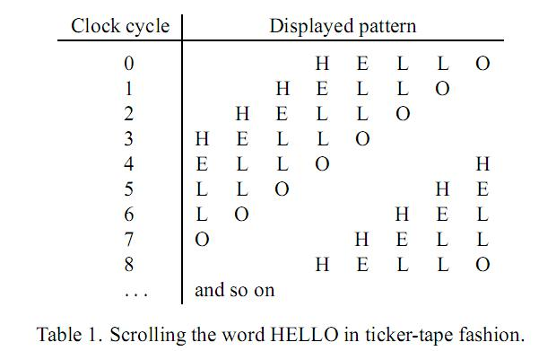
Table 1. Scrolling the word HELLO in ticker-tape fashion

3. Design Entry
Part 1:
part1_2.vhd (top-level entity):
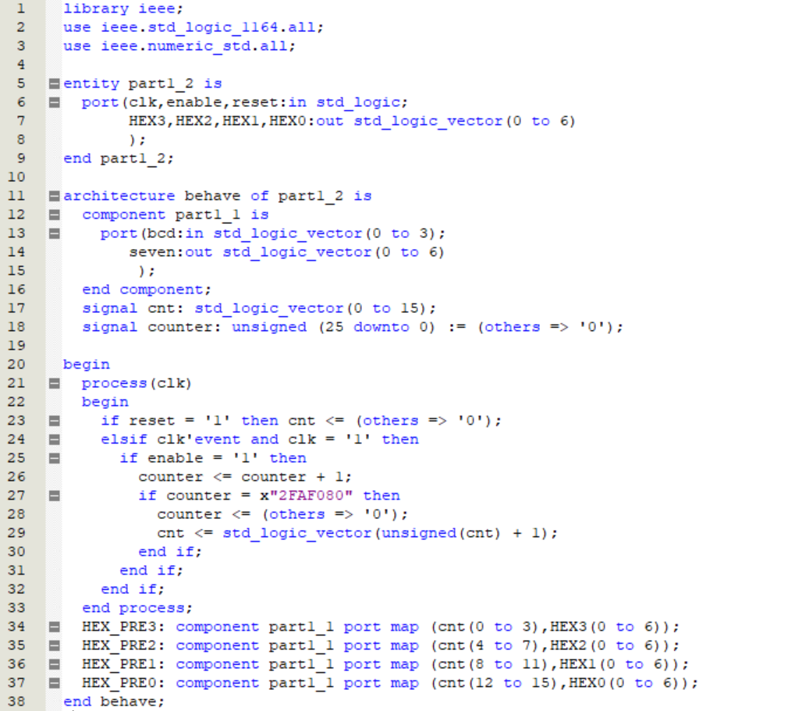

part1_1.vhd (component):
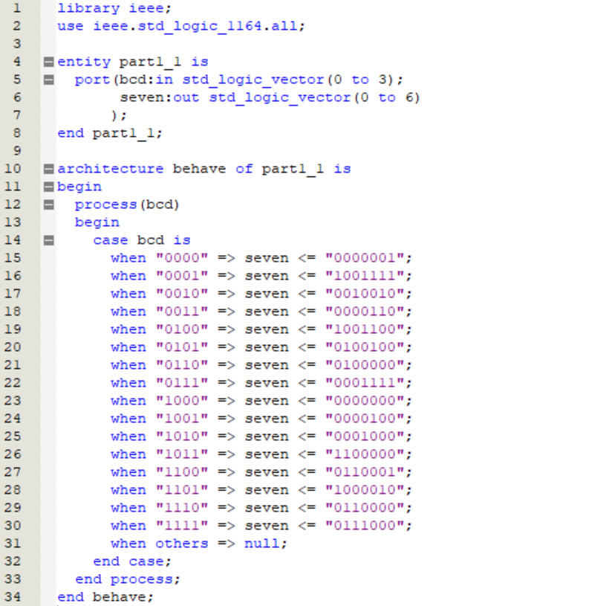

Part 2:
part2.vhd :
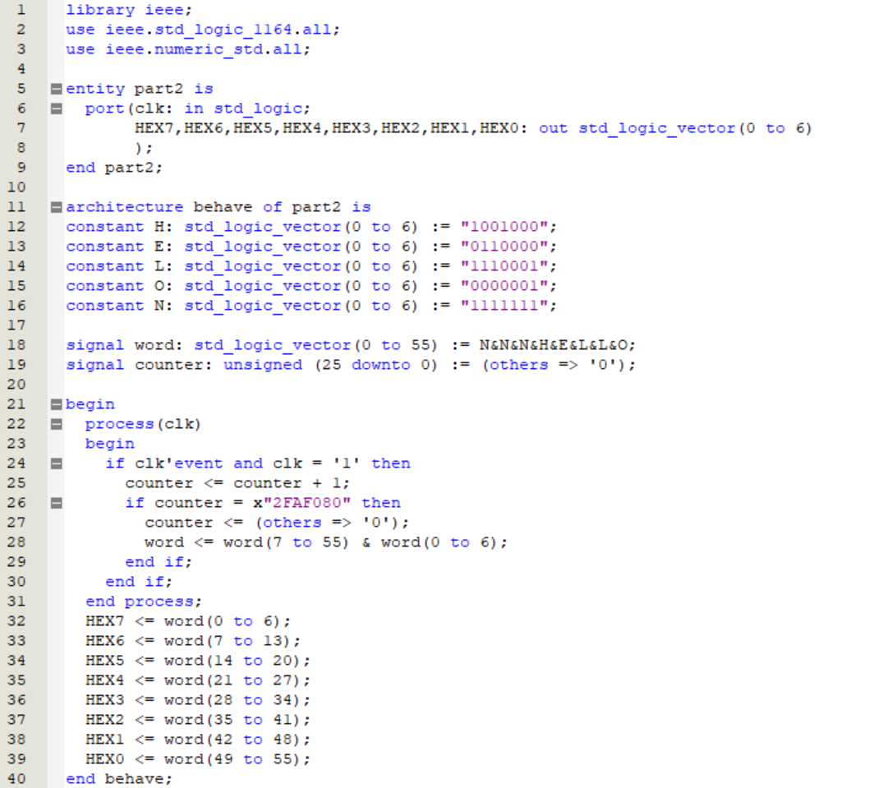

4. Simulation and Synthesis Results
Part 1:
For every 4 detected rising edges of the clock, the counter increments its count if the enable signal is asserted. When the enable signal is low, the value of the counter remains unchanged. The counter is reset to 0 by using the reset signal.
0000 to 000A count right and 000F to 0010 carry right. 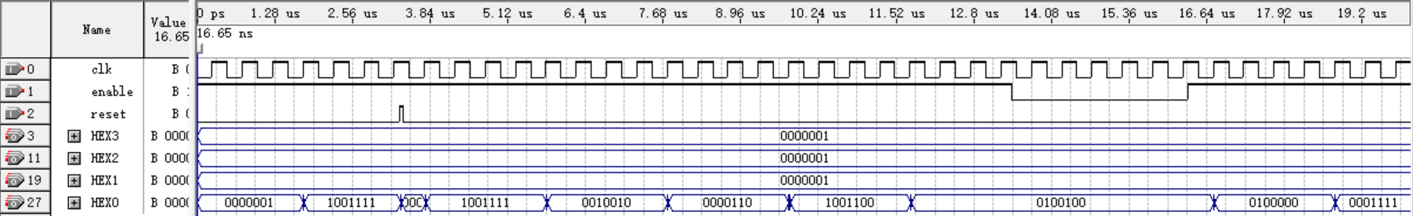
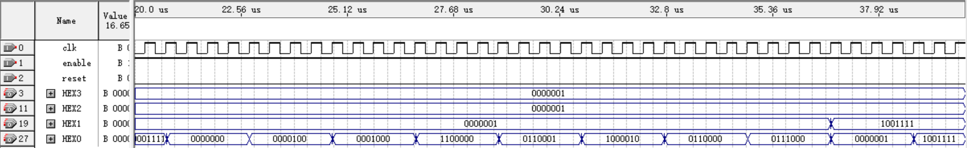
Use the Quartus II RTL Viewer to see how Quartus II software synthesizes 4-bib counter:
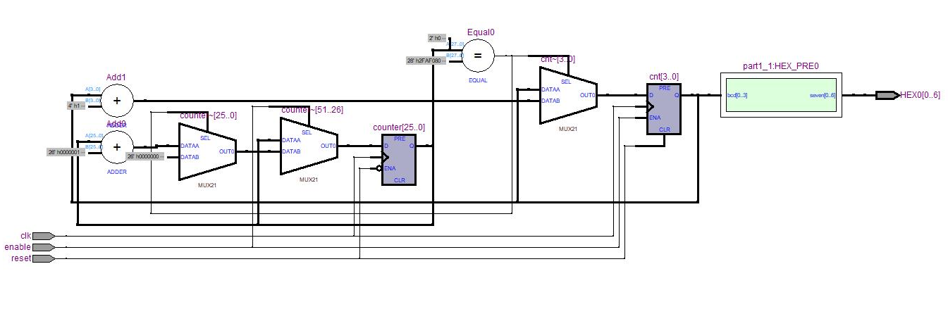

Part 2:
For every 4 detected rising edges of the clock, the letters move from right to left. Upon cycling, the "NNNHELLO" displayed on the digital tube returns to its original state.
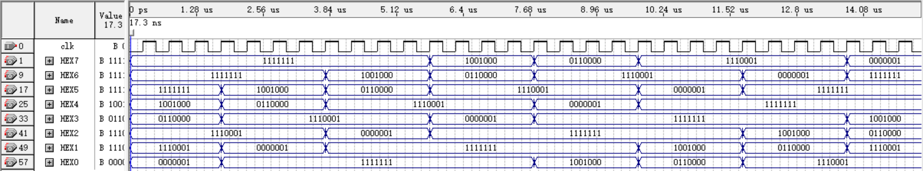

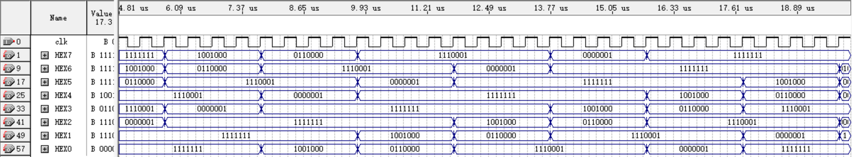

5. Experimental Results
Part 1:
Experimental Results | Analysis
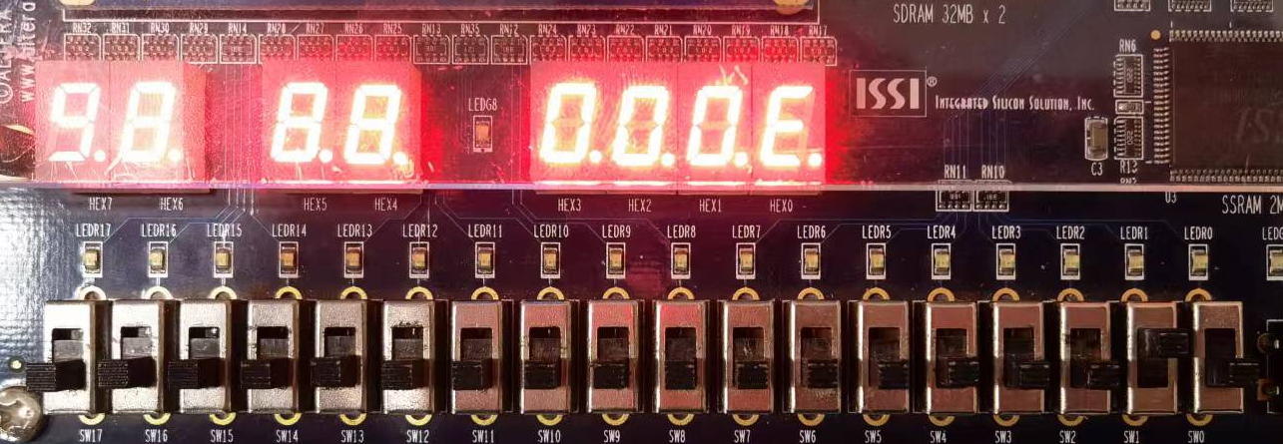 | For every second that passes, the counter adds one if the enable signal is  asserted.  When the enable signal is low, the value of the counter remains unchanged.  The counter is reset to 0 by using the reset signal.  One digit "000E" is  displayed correctly.  The two-digit "001C"  display is correct.  The two-digit "00A7"  display is correct.
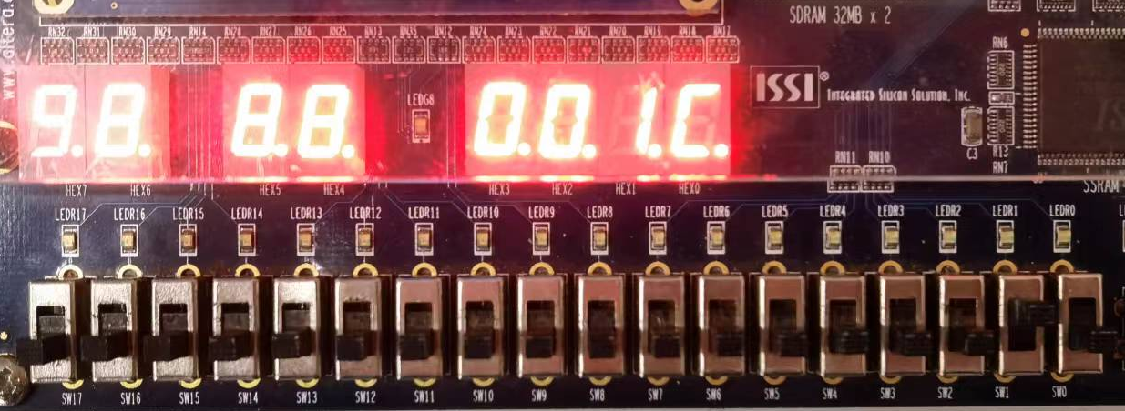
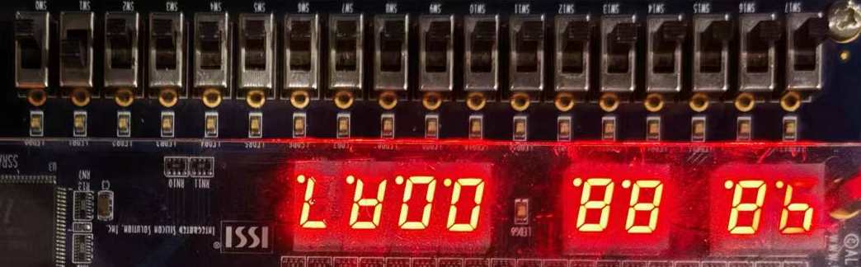

Part 2:
Experimental Results | Analysis
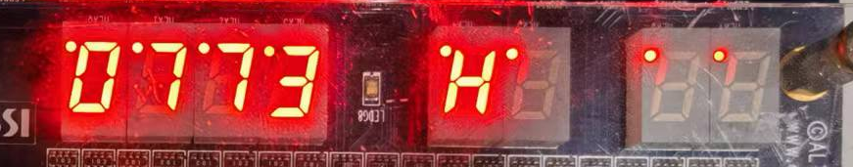 | Upon cycling, the "NNNHELLO" displayed on the digital tube returns to its original state.  From "NNNHELLO" to  "HELLONNN" to  .."LONNNHEL".
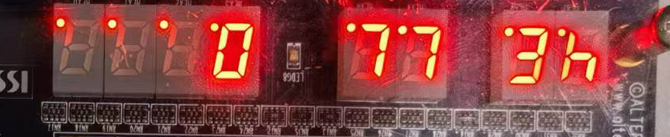
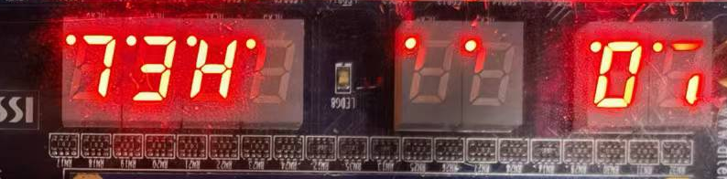

6. Discussion and Conclusion
Problem I:
In part1, I initially wanted to create a component that represents a T-trigger and use a for-generate statement to create sixteen triggers. The sixteen-bit counter is realized by using the T and Q relationships between these triggers. This is possible without adding the function of crossover frequency to the sixteen-bit counter.
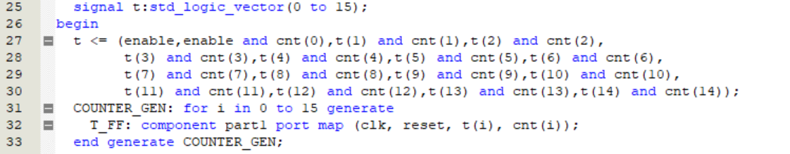
But if you want to realize the frequency division, then you have to insert these triggers into the if-then statement. Whenever the if condition is met, the trigger is executed, which means that when the value of the counter is "2FAF080", the trigger is executed once, and an output is obtained, thus adding one to the counter. The issue is that these triggers are derived from components that cannot be utilized in if-then statements. Of course, writing sixteen triggers in an if-then statement is laborious.
Instead of modifying the internal structure of the counter, I used a different approach. Whenever the counter's output needed to be incremented by one, I converted its output to an unsigned number and added one directly to it. Then, I converted the obtained result back to the original logic vector. This allowed me to achieve the desired outcome without altering the counter's internal structure.
Conclusion:
Through this experiment, I have a deeper understanding of process statements and concurrent statements, and a more intuitive understanding of how if-then statements can only be used in processes. And how to use the Quartus II RTL Viewer to see how the Quartus II software synthesizes the circuit.
The thing that struck me the most was that the component statement cannot be used in an if-then. Quartus has been giving me errors about this for a long time, and it gives some advice that has nothing to do with this problem. It's true that a component can't not exist just because it doesn't satisfy a condition, it can't exist just because it satisfies a condition.

